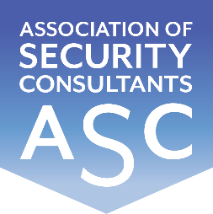

Certificate of Membership
This is to certify that
Anthony Chebrika
has been enrolled as a corporate member of the
Association of Security Consultants as a
Registered Independent Security Consultant
and is pledged to maintain its code of professional competence
and integrity.
Date of Enrolment: Membership No: Joe Connell
27th April 2022 CM 0003 Chairman

