Certificate of Membership
This is to certify that
Michelle Gunthardt
has been enrolled as an associate of the
Association of Security Consultants
and is pledged to maintain its code
of professional competence and integrity.

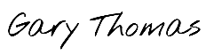
Date of Enrolment: Membership No: Gary Thomas
24th January 2024 AM4288 Chairman

