Certificate of Membership
This is to certify that
Andrew Buxton
has been enrolled as an associate of the
Association of Security Consultants
and is pledged to maintain its code
of professional competence and integrity.

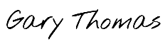
Date of Enrolment: Membership No: Gary Thomas
21st August 2023 AM4267 Chairman

