Certificate of Membership
This is to certify that
Neil Johns
has been enrolled as an associate of the
Association of Security Consultants
and is pledged to maintain its code
of professional competence and integrity.

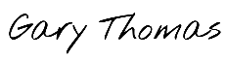
Date of Enrolment: Membership No: Gary Thomas
29th November 2023 AM4284 Chairman

