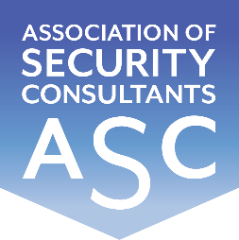

Certificate of Membership
This is to certify that
Rod Stobie RISC
has been enrolled as a member of the
Association of Security Consultants as a
Registered Independent Security Consultant
and is pledged to maintain its code of professional competence
and integrity.
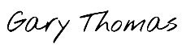
Date of Enrolment: Membership No: Gary Thomas
25th March 2024 FM 2256 Chairman

